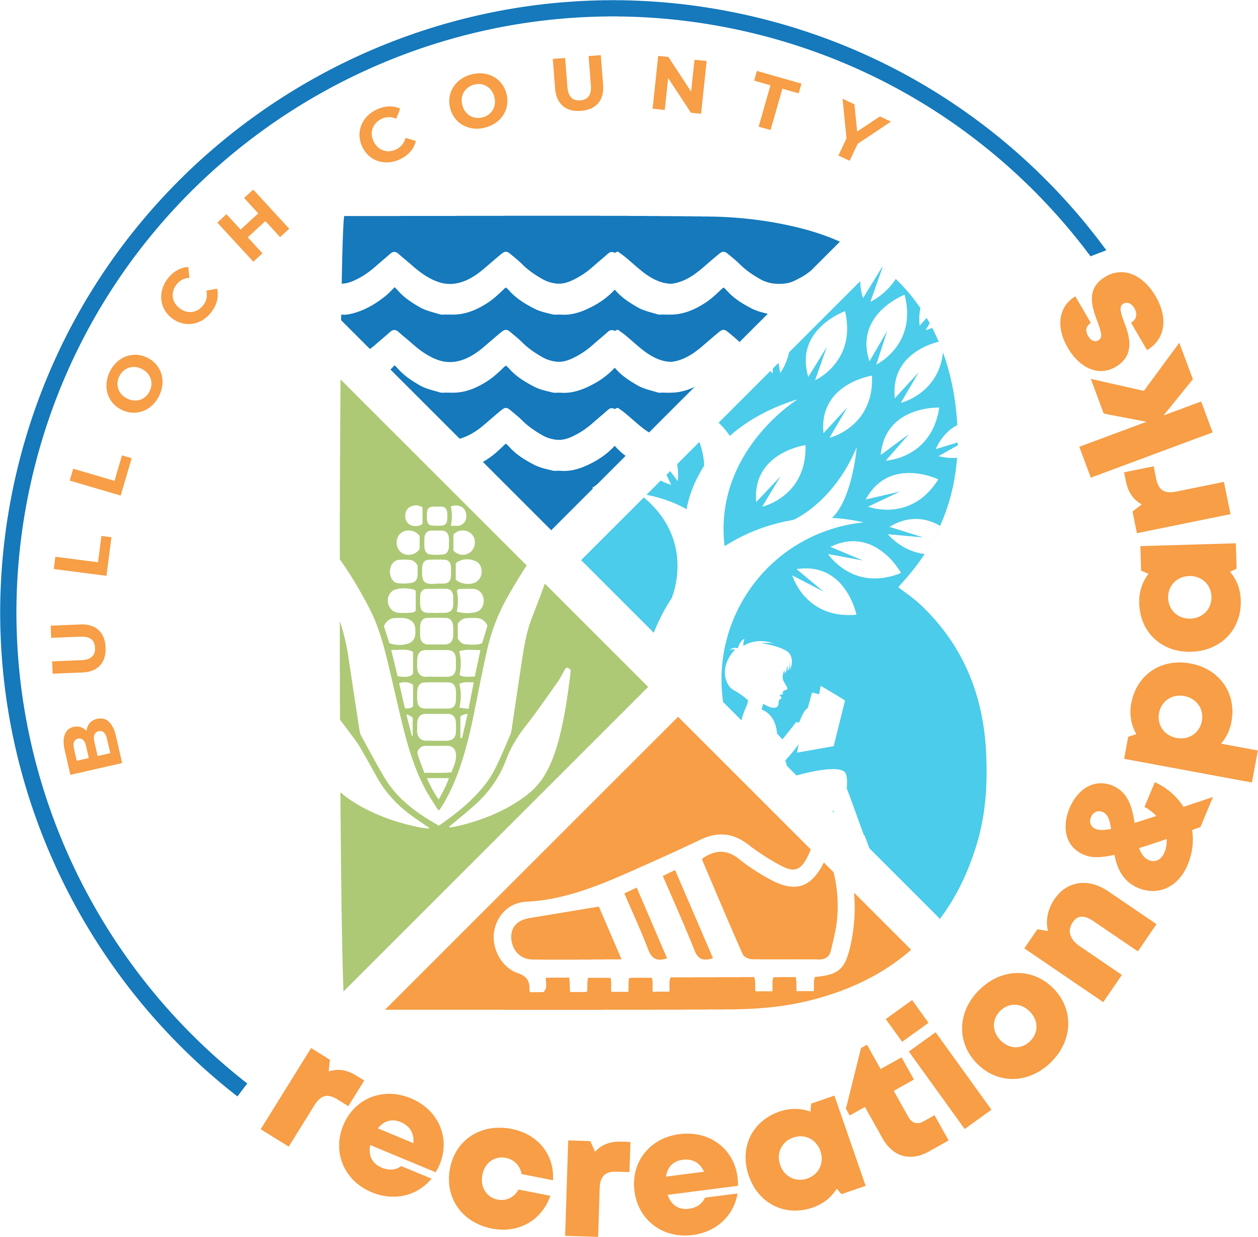

FALL 2025
VOLUNTEER COACHES APPLICATION



Dear Coach,

Football, Cheerleading, and Soccer season has arrived once again. As always, your commitment is appreciated, and we need your help to make the 2025 season a success for our community’s youth and the Bulloch County Recreation and Parks Department. All interested volunteers are encouraged to get involved so that we can make this season another great one for the kids.

If you are interested, please fill out the attached Volunteer Coaches Application completely! This needs to be turned into the main office (Honey Bowen Building) on Fair Road by Friday, August 22nd. Office hours are Monday – Friday, 8:00am to 5:00pm. If you know of anyone else who is interested in coaching or helping you, please have them come by the office to pick up an application ASAP! *Please be aware that completing the application does not guarantee a coaching position. The Recreation Department will notify you if you are assigned to a team.

ALL COACHES MUST BE CERTIFIED PRIOR TO THE START OF THE SEASON.
YOU MUST ATTEND THE HANDS-ON CLINIC/RULES MEETING.

MANDATORY!!!!
HANDS ON CLINIC & RULES MEETING:

Football
Date: Thursday, August 28th
Time: 6:00pm – 7:00pm
Location: Mill Creek Regional Park, Field 9
Coordinator: Austin Stanford – (912) 489-9083 OR astanford@bullochrec.com

Soccer
Date: Thursday, August 28th
Time: 6:00pm – 7:00pm
Location: Mill Creek Regional Park, Field 14
Coordinator: Ashton Faircloth – (912) 489-9057 OR afaircloth@bullochrec.com

Please consider giving your time this year to help the youth in our community have a great football, cheerleading, and soccer season! We thank you again for your help and look forward to working with you this season.

Sincerely,

Ashton Faircloth
Athletic Program Supervisor
912-489-9057
afaircloth@bullochrec.com

1 Max Lockwood Drive
PO Box 408
Statesboro, GA 30458 (30459)
www.bullochrec.com

Policies and Procedures for Athletic Coaches

Volunteer Coach
BCRP welcomes all volunteers who meet the requirements to become a coach. However, during games there is a limit of 3 coaches who can actively work with a single team. Extra volunteers are welcome during practice session if they have met the requirements of the BCRP.

Application
Any person wishing to volunteer coach must fill out an application and consent form. The coaching application is an information sheet that allows the recreation departments staff to keep important information about coaches on file. The criminal background check form allows the Bulloch County Sheriff’s Department to retrieve any criminal records. Applicants with records on file must meet with the Athletics Division Manager to be allowed to coach. A new application must be completed each season.

Required Training
To coach in our league, coaches must be certified through NAYS. NAYS is a national organization whose sole purpose is to make youth sports better for kids. Coaches will receive a certificate of completion once the course is passed.

Volunteer Coach Evaluation
All volunteer coaches for the BCRP are monitored throughout the season. The staff attempts to ensure that the coaches:
- Have a thorough understanding of first aid principles in case an injury occurs
- Organize practices that are fun and challenging for all the players
- Demonstrate fair play and sportsmanship
- Have knowledge of rules for the sport that he/she coaches

Guidelines For a Coach’s Expulsion
BCRP maintains the right to suspend the coaching privileges of any individual who they feel is unable to carry out the responsibilities of a youth sports coach.

Coach Selection
- Prospective coaches must apply for team assignments by obtaining a coach’s application from the Administration Offices (county-wide) or Athletic Program Supervisors. This form must be completed and returned during the designated participation registration dates for that sport. This form must be completed on a season-to-season basis no matter how long you have coached in the program.

2. All coaches must complete a coach’s application including a Background Consent Form to be considered for a head or assistant coach position in all athletic programs. A criminal background check is mandatory for ALL coaches. A written authorization form allowing BCRP to order an individual criminal background is required. Individual applicants shall be disqualified from the coach selection process if they are convicted of the following:
  - Any crimes against children
  - Any felony conviction involving violence
  - Any sexual offense
  - Any substance abuse offense

Said staff shall approve the list of coaches based on the following criteria:

- Previous coach evaluation(s) and incident report reviews
- Years of experience
- Playing or other coaching experience
- Perceived coaching effectiveness
- Parent evaluation of coach
- Experience in developing players and past practice frequency

- The Athletic Staff will review all coaching applications on a first come/first serve basis.

- Applicants will be discussed and evaluated by the Athletic Supervisor based on experience and attributes that would be of the most value to the league and to the players.

- Applicants must be approved by Athletic Supervisor and Athletics Division Manager.

- The number of teams in a division will determine the number of coaches.

- A coach returning in the same age group for the same sport will have the first opportunity to coach a team again, if he or she meets the other requirements listed as criteria.

- An assistant coach who helped coach that team will be next in line for the team he or she helped with.

- A coach who coached in that sport in the last year in another age group, will have the first opportunity to move up or down in age groups, when an opening occurs.

- A coach from the previous sport will be next in line.

- Volunteers will be recruited from interested persons in that sport.

- Parents from the team without a coach will be next in line for coaching.

- No Head Coach or Assistant Coach may change teams while he or she has a child playing in the same age group which he or she is coaching.

- An assistant coach may change to become a Head Coach, if last year’s Head Coach does not return to the team he assisted.

3. All Head and Assistant Coaches must attend the required coach’s clinics each year in each sport he or she wishes to coach. Failure to attend will cause loss of his or her team. Coaches will not be allowed to conduct practices or games on county facilities until certification is completed or renewed. This is the responsibility of the league coordinator, that all league coaches have completed the above clinics.

4. Each team is allowed a Head Coach and up to Assistant Coach only. After team assignment postings are complete, any parent who would like to assist the coaches may do so if they meet BCRP requirements. However, during the game, there is always a 3-coach limit.

Rules for Coaches

- Coaches will study the rules of the game, observe the rules, and attempt to improve himself or herself through the knowledge of the sport.
- Coaches should remember that you are out there for the CHILDREN and not to draw attention to yourself but encourage the children in learning and playing.
- Coaches should shape their character and conduct to be a worthy example to the youth under their jurisdiction.
- Coaches should be fair and unbiased in their decisions regarding the playing of children.
- Coaches should cooperate and be professional in their association with fellow coaches and Officials. They should avoid any activity that would cause them or the Recreation Department public embarrassment.
- Coaches should be dignified, courteous, positive, friendly, calm, and always alert; should never be rude, arrogant, or overbearing during practice and games.
- Coaches should keep in mind that the children are more important than the game or the ambitions of any player or parent.
- Coaches will not use tobacco products, drugs, or alcoholic beverages on or in the vicinity of playing field on the day of a game or during practice.
- All coaches are responsible for returning their team’s equipment after their last game. (Only Baseball/Softball)
- Any coach having knowledge of players in the league or tournament recreational league in a Recreation Department or GRPA tournament under false age or identification will be suspended indefinitely.
- All-Star Coaches, upon accepting the responsibility to coach, are required to accompany their team to all playoffs. Failure to do so will result in immediate suspension from the program.

Game Participation Rules
  - Coaches not playing their players the required time must start the players the next game and let them play their required playing time for both games.
- Penalty: For failure the second time, the coach will be suspended for 1 game.

Any coach acting in any un-sportsmanlike manner or in any way that could prove detrimental to the league, players, officials, or spectators will be subject to disciplinary action by the Recreation Department.

Disciplinary actions will be imposed on a Head or Assistant Coaches regarding:
    - Language unbecoming to the league (suspension next game and must leave the park).
    - Fighting (suspension indefinitely).
    - Touching or striking an official (suspension).
    - Un-sportsmanlike conduct at an athletic event (suspension next game and must leave the park).
    - Damage to recreation property (suspension indefinitely).
    - Thrown out of a game (suspension indefinitely).
    - Failure to follow return to play protocols. (suspension indefinitely)
- Second offense of any of the above infractions will result in coaching status review by Staff and Director before being allowed to coach another game.

Volunteer Sports Coaches Application

(You must be 18 or older to be a volunteer coach)
NAME ___________________________________________________________________________________________

STREET ADDRESS ________________________________________________________________________________

CITY _____________________________________ STATE _________________ ZIP _____________________

CELL PHONE # ______________________________ DATE OF BIRTH ____________________________________

E-MAIL ADDRESS ________________________________________________________________________________
FOOTBALL SOCCER
Which group would you like to coach?
___ U-6 (4 & 5 years old)
___ U-8 (6 & 7 years old)
___ U-10 (8 & 9 years old)
___ U-12 (10 & 11 years old)
___ U-14 (12 & 13 years old)
Indicate area you would like to coach in:
___ Brooklet ___ Portal
___ Nevils ___ Statesboro
___ Stilson

Staff Contact: Ashton Faircloth: 912-489-9057 or afaircloth@bullochrec.com

Which group would you like to coach?
___ Pee Wee Flag (5 & 6 years old)
___ Tiny Mite Tackle (7 & 8 years old)
___ Minor Tackle (9 & 10 years old)
___ Midget Tackle (11 & 12 years old)
___ Tiny Minor Girls Flag Football (7 & 9 years old)
___ Midget Girls Flag Football (10 & 12 years old)
Indicate area you would like to coach in:
___ Brooklet ___ Portal
___ Nevils ___ Statesboro
___ Stilson
Staff Contact: Austin Stanford: 912-489-9083 or astanford@bullochrec.com

CHEERLEADING VOLLEYBALL
Which group would you like to coach?
___ Tiny Mite Tackle (4 & 5 years old)
___ Minor Tackle (6 – 8 years old)
___ Midget Tackle (9 - 12 years old)
Indicate area you would like to coach in:
___ Brooklet ___ Portal
___ Nevils ___ Statesboro
___ Stilson
Staff Contact: Austin Stanford: 912-489-9083 or astanford@bullochrec.com

Which group would you like to coach?

___ Flea (7 & 8 years old)
___ Mite (9 & 10 years old)
___ Midget (11 & 12 years old)
___ Junior (13 & 14 years old)

Staff Contact: Ashton Faircloth: 912-489-9057 or afaircloth@bullochrec.com

Do you have a child participating in our program: Yes _____ No _____

Child’s Name: _____________________________________ Date of Birth: ___________________________________

If no child, are you a college student? Yes _____ No _____ If yes are you coaching for a class? Yes _____ No _____

Is there someone you are interested in coaching with? _____________________________________________________

I, the undersigned, understand that as a coach of a youth sports league that I will be expected to follow all the rules and regulations as set forth by the Bulloch County Recreation and Parks Department and attend all required trainings. I also understand that a failure to comply with all the rules can result with my termination as a volunteer coach.
Signature: ________________________________________________ Date: ___________________________________

Please submit applications and driver’s license to:
Ashton Faircloth at afaircloth@bullochrec.com or BCRP PO Box 408, Statesboro, GA 30459
Coaches’ Code of Ethics

- Place the emotional and physical well-being of my players ahead of a personal desire to win.
- Treat each player as an individual remembering the large range of emotional and physical development for the same age group.
- Provide a safe playing situation for all players.
- Review and practice the basic first aid principles needed to treat injuries of the players.
- Organize practices that are fun and challenging for all of the players.
- Lead by example in demonstrating fair play and sportsmanship to all players.
- Provide a sports environment for the team this is free of drugs, tobacco, and alcohol, and I will refrain from their use at all youth sports events.
- Be knowledgeable in the rules of each sport that I coach and teach these rules to the players.
- Use coaching techniques appropriate for each of the skills that I teach.
- I will remember that I am a youth sports coach, and that the game is for children and not adults.

Disciplinary Procedures
Coaches found to be in violation of any of the policy and procedures set forth in this manual will be addressed as follows:

First Violation: Verbal Counsel of violation with exceptions for compliance with written documentation by the athletic supervisor and league coordinator.

Second Violation: Written warning of violation with expectations for compliance by the athletic supervisor (suspension for 2 games).

Third Violation: Suspension from coaching any sport with BCRP and written expectations of compliance by the athletic supervisor.

- Any Confirmed Violations may result in immediate dismissal

Appeals Process

This process involves any Parent/Coach or spectator wishing to appeal a formal parks and recreation staff decision regarding a suspension, probation or dismissal from a department sponsored activity or program.

Any person may appeal an action made by the department by writing, in detail, within five calendar days of action taken by department officials. Appeals may be brought to the administrative office Monday-Friday, 8:00-5:00pm or mailed to Attention: Athletics Division Manager, P.O. Box 408, Statesboro, GA, 30459. The Athletics Division Manager will review the Appeal and the principals involved in the action and a decision rendered regarding the appeal within two weeks of receiving a written request.

ANY POLICE OR PROCEDURE NOT COVERED IN THIS MANUAL WILL BE DETERMINED BY THE BULLOCH COUNTY RECREATION AND PARKS DEPARTMENT AS INDIVIDUAL AND GENERAL SITUATIONS OCCUR.

Printed Name: ____________________________________ Date: _____________________

Signature: Date: ___________________

