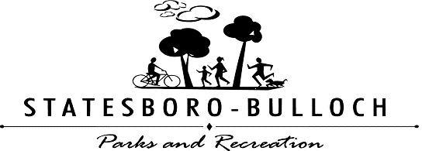
PLAYER CONTRACT FORM
Please print
Participant’s Name: ___________________________________________________________
Team Name: _________________________________________________________________
Age: ____ Birthdate: ___/___/___
Sport: (please circle) Football Basketball Softball Kickball Soccer Wiffleball
Street Address: ___________________________ City: ______________ State: ____ Zip: _______
Primary Telephone: ______________________
Email Address: __________________________
Please Check: ___ Statesboro Resident ___ County Resident
___ Male ___ Female

Please read the following statements and sign below:
I fully understand that in case of an accident and/or injury, I will not hold the Statesboro-Bulloch County Parks and Recreation Department, its staff, nor the city of Statesboro responsible. I also understand that any incorrect information given on my part to the Recreation Department may result in suspension from participating in activities offered by the Statesboro-Bulloch County Parks and Recreation Department.

______________________________ __________
Signature Date

For Office Use Only:

Receipt Number: _____________ Amount Paid: ____________ Staff: _____________

